Step 1: About Job Zones
By pressing the next button, the student should see a screen that begins to introduce them to the concept of job zones as shown in the picture below.
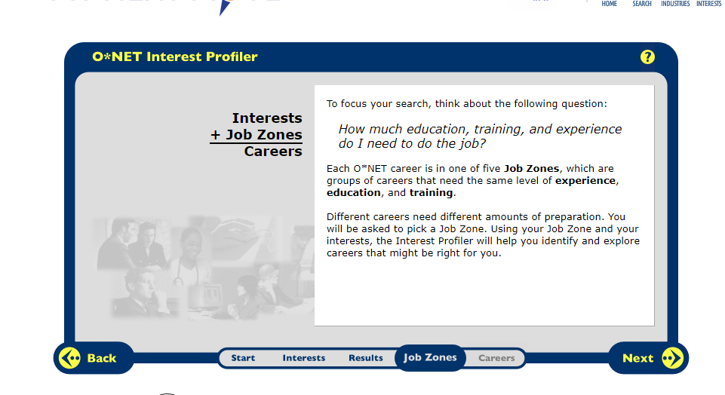

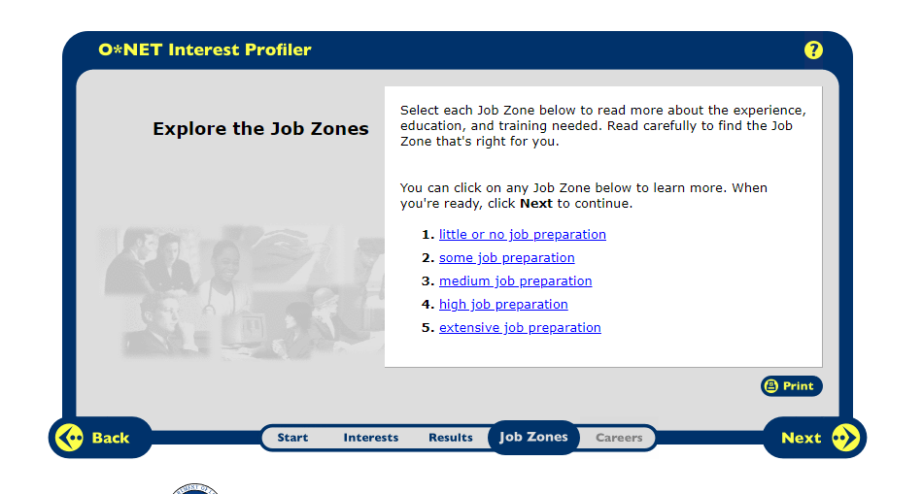
By clicking on the Next Button again, students will see five job zone alternatives and they may click on the link to learn more about them.

Step 2: Select a Job Zone
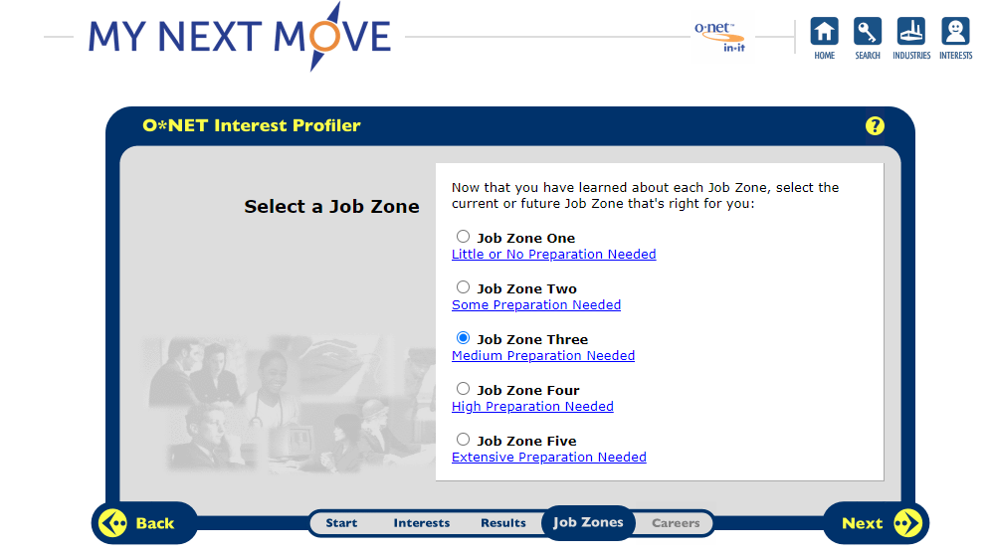
After the screen explaining the different job zones, the student will reach this screen. Here they can select which job zone they would like to start in. Students will get a confirmation screen on which job zone they picked on the next screen. Students will have the opportunity to easily change job zones as they explore careers.

Step 3: Explore Careers
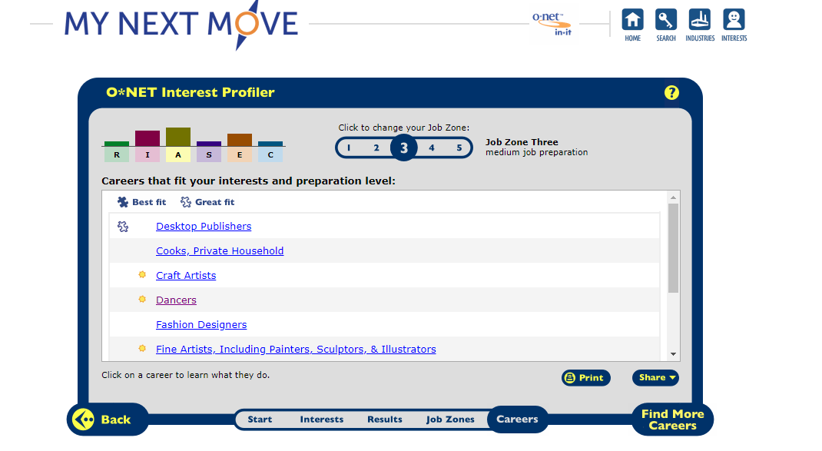
By clicking on the Next Button, the student will be led to a list of careers they may be interested in.

The Bar on the top of the screen can be used to change between job zones.

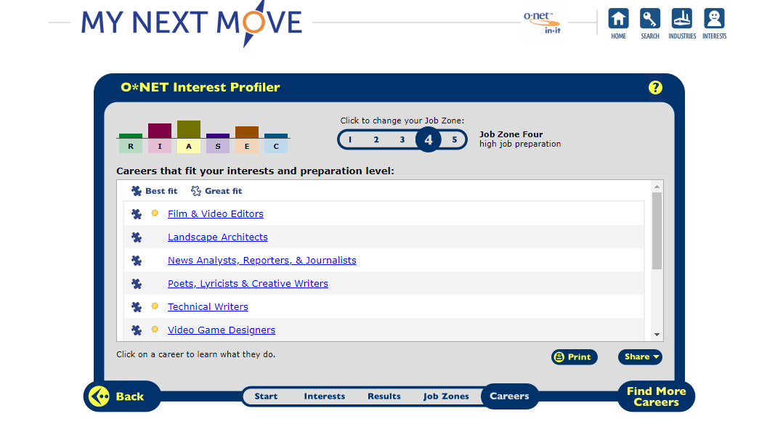

After the student clicks on a career, another window will pop up. This window will be like the one shown below. It will give details of what the career entails. Some may have a video attached. To leave this screen, just have the student close the window.

